Name: #
MATH 205
Homewor
- Researchers collected samples of water from streams in the Adirondack Mountains to investigate the effects of acid rain. They measured the pH (acidity) of the water and classified the streams with respect to the kind of substrate (type of rocks over which they flow). A lower pH means the water is more acidic. Are there differences in terms of acidity between the different types of substrate (limestone, mixed, and shale)?
  - Screenshot of numerical summaries by substrate


  - Screenshot of boxplots by substrate
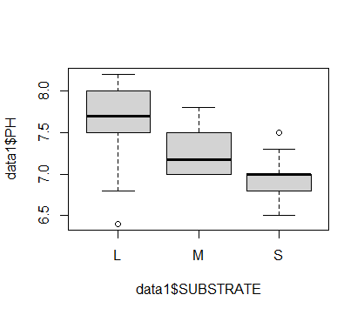
  - Null and alternative hypotheses
u1 = mean ph by limestone
u2 = mean ph by mixed
u3 = mean ph by shale
Null Hypothesis : H0 : u1 = u2 = u3
Aletrnate : H1: u1 != u2 != u3
  - Appropriate test results
test <- aov(PH ~ SUBSTRATE, data=data1)
> summary(test)
Df Sum Sq Mean Sq F value Pr(>F)
SUBSTRATE 2 19.85 9.927 131.6 <2e-16 ***
Residuals 169 12.75 0.075
---
Signif. codes: 0 ‘***’ 0.001 ‘**’ 0.01 ‘*’ 0.05 ‘.’ 0.1 ‘ ’ 1

  - Check assumptions
    - Each group is normally distributed
Limestone group is approximately normal distributed. Mixed group is slightly right-skewed and finally shale group is left-skewed

    - Ratio of lowest SD and highest SD
0.3241/0.2151 = 1.5067

    - Independence
We have independent samples

  - Conclusion( make two conclusions. The first conclusion should be the statistical conclusion and the second conclusion should be an explanation of the statistical conclusion to people with no statistical background knowledge)
The Pvalue of the test is very small (<0.05) hence we rejct H0. Thus we conclude that the ph of all 3 substrates are different.

- A tire manufacturer tested the braking performance of one of its tire models on a test track. The company tried the tires on 10 different cars, recording the stopping distance for each car on both wet and dry pavement. Is there a difference between dry and wet pavements for this type of tire in terms of braking performance?
  - Null and alternative hypotheses
#H0: There is no difference between dry and wet pavements
#H1 : There is difference between dry and wet pavements

  - Histogram of differences between wet and dry pavement
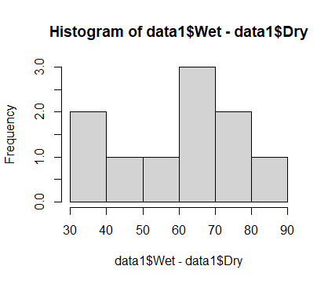
  - Appropriate test result
t.test(data1$Dry, data1$Wet, alternative = "two.sided")

Welch Two Sample t-test

data: data1$Dry and data1$Wet
t = -11.644, df = 13.798, p-value = 1.606e-08
alternative hypothesis: true difference in means is not equal to 0
95 percent confidence interval:
-74.62073 -51.37927
sample estimates:
mean of x mean of y
139.4 202.4

  - Conclusion( make two conclusions. The first conclusion should be the statistical conclusion and the second conclusion should be an explanation of the statistical conclusion to people with no statistical background knowledge)
The pvalue < 0.05, hence we reject H0
Thus we conclude that there is difference between wet and dry pavements

- Many states and localities now collect data on traffic stops regarding the race of the driver. The initial concern was that Black drivers were being stopped more often. With more data in hand, attention has turned to other issues. For example, data from 2533 traffic stops in Cincinnati report the race of the driver (Black, White, or Other) and whether the traffic stop resulted in a search of the vehicle. Is there evidence that race is a factor in vehicle searches?

 | Black | White | Other | Total
Not Searched | 787 | 594 | 27 | 1408
Searched | 813 | 293 | 19 | 1125
Total | 1600 | 887 | 46 | 2533

  - Explanatory variable and type
Race , Qualitative
  - Response variable and type
Vehicle searches, Qualitative
  - Null and alternative hypotheses
H0 : Race and Vehicle are independent
H1: Race and Vehicle are dependent
  - Bar chart of proportions (use Excel)

  - Appropriate test result
m= matrix(c(787,594,27,813,293,19),2,3,byrow = T)
> m
[,1] [,2] [,3]
[1,] 787 594 27
[2,] 813 293 19
> chisq.test(m)

Pearson's Chi-squared test

data: m
X-squared = 73.253, df = 2, p-value < 2.2e-16

  - Conclusion( make two conclusions. The first conclusion should be the statistical conclusion and the second conclusion should be an explanation of the statistical conclusion to people with no statistical background knowledge)
Pvalue is very small, hence we reject H0, and conclude that race and vehicle are dependent variables

- Does a person’s cholesterol level tend to change with age? This dataset was collected from 1406 adults aged 45 to 62.
  - Explanatory variable and type
Age, Qualitative
  - Response variable and type
Cholestrol level, Quanitative
  - Screenshot of scatterplot + regression line
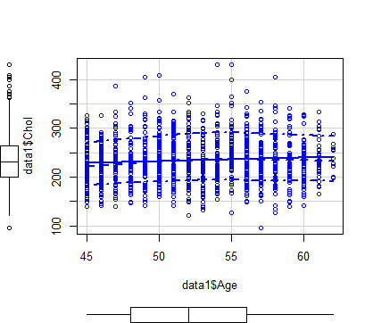
  - Correlation coefficient
0.0798

  - Regression model
model <- lm(Age ~ Chol, data = data1)
summary(model)

Call:
lm(formula = Age ~ Chol, data = data1)

Residuals:
Min 1Q Median 3Q Max
-8.1979 -4.1237 -0.2663 3.9293 9.8573

Coefficients:
Estimate Std. Error t value Pr(>|t|)
(Intercept) 50.510338 0.657796 76.787 < 2e-16 ***
Chol 0.008244 0.002750 2.998 0.00276 **
---
Signif. codes: 0 ‘***’ 0.001 ‘**’ 0.01 ‘*’ 0.05 ‘.’ 0.1 ‘ ’ 1

Residual standard error: 4.771 on 1404 degrees of freedom
Multiple R-squared: 0.006361, Adjusted R-squared: 0.005654
F-statistic: 8.989 on 1 and 1404 DF, p-value: 0.002764

  - Check assumptions
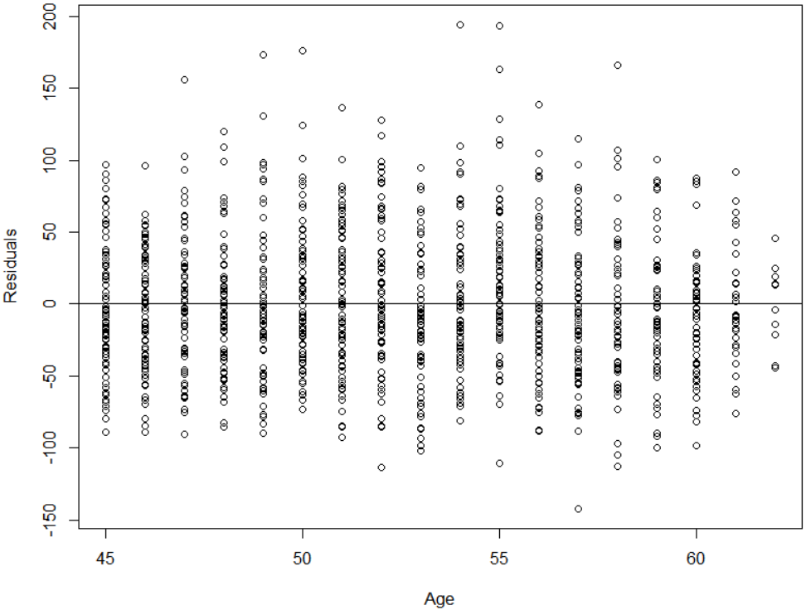
    - Linear
There is no obvious pattern in plot, hence assumption met.
    - Constant variation
Spread of plot are roughly same across the plot, hence assumption met
    - Normality of residuals
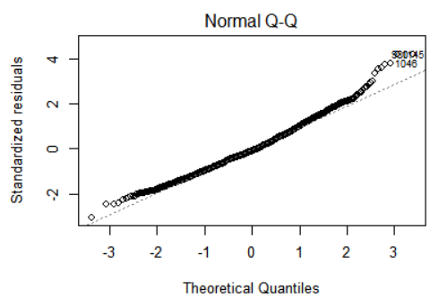
QQplot has a roughly straight line, thus assumption met
    - Independence
They are independent variables

  - Conclusion( make two conclusions. The first conclusion should be the statistical conclusion and the second conclusion should be an explanation of the statistical conclusion to people with no statistical background knowledge)

p-value is small (i.e., less than 0.05), hence we reject null hypothesis. Thus we can say that there is a linear relationship between Age and Cholesterol level.

